Alpha - Version
Requirements Gathering Document
Project Overview

Project Manager: Bheka Mbhele
Project: Sand Lab Testing System
Plant: High Chrome Ball Plant
Version: 1.0.0.0
Prepared by: Tsundzukani Martin Nkuna
From Date: 2025/ 10/ 27 To Date: 2025/ 10/ 28

Project Objectives: The objective of the project is to allow Users to Register, Login and Manage Sand Lab Test Records

Table of Contents
INTRODUCTION 3
BUSINESS REQUIREMENTS 3
1.1 Business Goals: 3
BUSINESS RULES 5
2.1 Data Security / Confidentiality 5
2.2 Data Integrity & Validation 5
2.3 Access & Permissions 5
2.4 System Availability & Constraints 5
2.5 Performance & Responsiveness 5
FUNCTIONAL REQUIREMENTS 6
3.1 User Design Diagram 6
3.1.1 Use Cases Figure 6
3.1.2 Use Stories 7
3.1.2.1 Use Case 01: Register 7
3.1.2.2 Use Case 02: Login 7
3.1.2.3 Use Case 001: Recover Login Details 7
3.1.2.4 Use Case 03: Insert Sand Samples 7
3.1.2.5 Use Case 04: Update Sand Samples 7
3.1.2.6 Use Case 05: View Sand Samples 7
3.1.2.7 Use Case 06: Flag Sand Samples 7
3.2 System Design Diagram 8
3.2.1 Activity Flow 8
3.3 Database Design Diagram 9
3.3.1 ERD – Entity Relationship Diagram 9
NON – FUNCTIONAL REQUIREMENTS 10
4.1 Technical Requirements 10
4.1.1 Platform 10
4.1.2 Technology Stack 10
4.1.3 Architectural Design Patterns 10
4.2 Data Requirements 10
4.2.1 Data Storage 10
4.2.2 Data Input 10
4.2.3 Usability Requirements 10
4.3 Business / System Feature Requirements 11
4.3.1 User Management 11
4.3.2 Sand Samples Management 11
4.3.3 System Sand Samples Management 11
TIMELINE 12
RESOURCES 12
CONCLUSION 12

INTRODUCTION
This Requirements Gathering Template defines the foundational elements of the Sand Lab Testing System – Alpha Version, intended for implementation at the High Chrome Ball Plant. Under the guidance of Project Manager Bheka Mbhele and technical ownership by Tsundzukani Martin Nkuna.

BUSINESS RULES

Business Goals:
The Sand Lab Testing System for the High Chrome Ball Plant is being developed to allow users to register and log in to maintain records of tested sand samples from Line 1, Line 2, and Line 3.
For every user who registers on a given day, the system will maintain a record of:
- User ID – Primary Key
- First Name
- Surname
- Clock Number
- Email Address
- Password
- Position
- Cell Number
For login purposes, login details will be authenticated from the list of registered users.
- Email Address
- Password
Information to Record for Each Login User.
- Shift ID -Primary Key
- User ID -Foreign Key
- Shift 1, 2, 3
- Foreman Name
- Date and Time
For each sand batch produced on a given day, the system will record:
- Disa Log Sheet Information
  - Disa ID – Primary Key
  - Pattern ID – Foreign Key
  - Grade
  - Press Pour Temperature

- Pattern Sizes Information
  - Pattern ID – Primary Key
  - Scada ID – Foreign Key
  - Pattern Number
  - Mould Thickness
  - Pattern Size mm

- Scada Information
  - Scada ID – Primary Key
  - Batch Number
  - Coal Dust
  - Bentonite
  - New Sand
  - Return Sand
  - Water
  - Mix Time
  - Sand Temperature
    - Shake Out
    - Sand Mixer
  - Production Line

- User Inputs (What They Test For)
  - Test ID – Primary Key
  - Shift ID – Foreign Key
  - Disa ID – Foreign Key
  - Time of Test
  - Active Bentonite
  - Eff Bentonite
  - Moisture
  - Mouldability
  - C/S N/cm2
  - C/S N/cm2
  - C/S N/cm2
  - Permeability
  - Fines Indicator
  - Compatibility
  - Sand Tester

BUSINESS REQUIREMENT

2.1 Data Security / Confidentiality
- All Users Password will be stored as hashed value on Registration
- Only work email with domain @magotteauxgmsa.com will be allowed to register.
- Only Registered Users will be able to Recover their Details with Registered Email Address, Cell Phone Number or Clock Number
- Only Authorised System Developers will have Access to Database.

2.2 Data Integrity & Validation
- Only domain @Magotteuaxgmsa.com will be allowed as Email Address
- System validated not to accept null values
- Stored Procedure validated to store password as hash value
- No less than 10 Digits Cell Number will be accepted
- Ensure or avoid Data alteration at all costs

2.3 Access & Permissions
- The app will have Access limitations.
  - Registration – Users will be required to register first with work domain email @magotteuaxgmsa.com
  - Login – Only Registered User on the App will be granted access to Login
  - Forgot Email and Password – only Registered Users can recover their login details.
- Any Employee of Magotteaux GMSA with access to their email address will be given permission to access the application.

2.4 System Availability & Constraints
- The system must be accessible during standard plant operating hours (24/7), with scheduled downtime communicated 24 hours in advance.
- Automatic backups of all Sand Lab Testing Samples must occur every 24 hours.
- Non Magotteaux GMSA employee will have access to utilise the system.
- Only Registered Users will be able to login.

2.5 Performance & Responsiveness
- The system should retrieve and display query results within 3 seconds for normal data ranges.
- The System will support multiple users without performance degradation

FUNCTIONAL REQUIREMENTS

3.1 User Design Diagram

3.1.1 Use Cases Figure
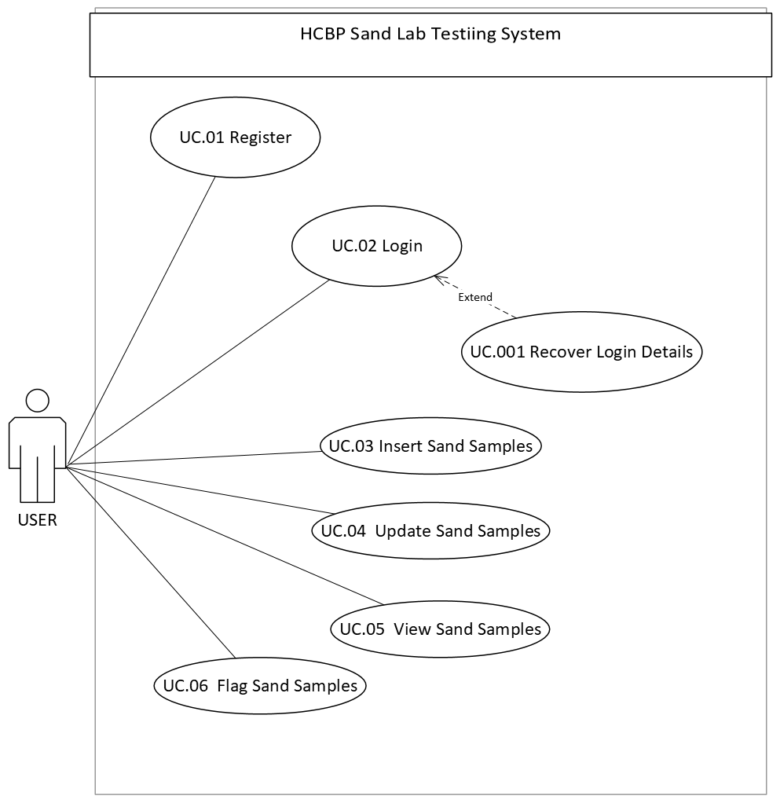

3.1.2 Use Stories

3.1.2.1 Use Case 01: Register
- First Time User, Must Register on the System
- Registered User Details will be stored on the Database
- Confirmation Email after Registration will be Sent to Registered Email Address

3.1.2.2 Use Case 02: Login
- Only Registered User will be authorised to Login
- Login Details Sent After Registration are to be used
- Registered Email Address and Password.

3.1.2.3 Use Case 001: Recover Login Details
- Only Registered User will be allowed to Recover login Details
- Registered User can recover login details, Password or Email Address
- They will recover Email Address using Cell Number or Clock Number
- They will recover Password using Email Address or Cell Number

3.1.2.4 Use Case 03: Insert Sand Samples
- Insert Sand Samples
- Input validation not to accept null values

3.1.2.5 Use Case 04: Update Sand Samples
- Retrieve Already Stored Sand Samples
- Update / Alter Sand Samples

3.1.2.6 Use Case 05: View Sand Samples
- View / Retrieve Sand Samples

3.1.2.7 Use Case 06: Flag Sand Samples
- Retrieve Already Stored Sand Samples
- Flag out of Specifications Sand Samples

3.2 System Design Diagram

3.2.1 Activity Flow
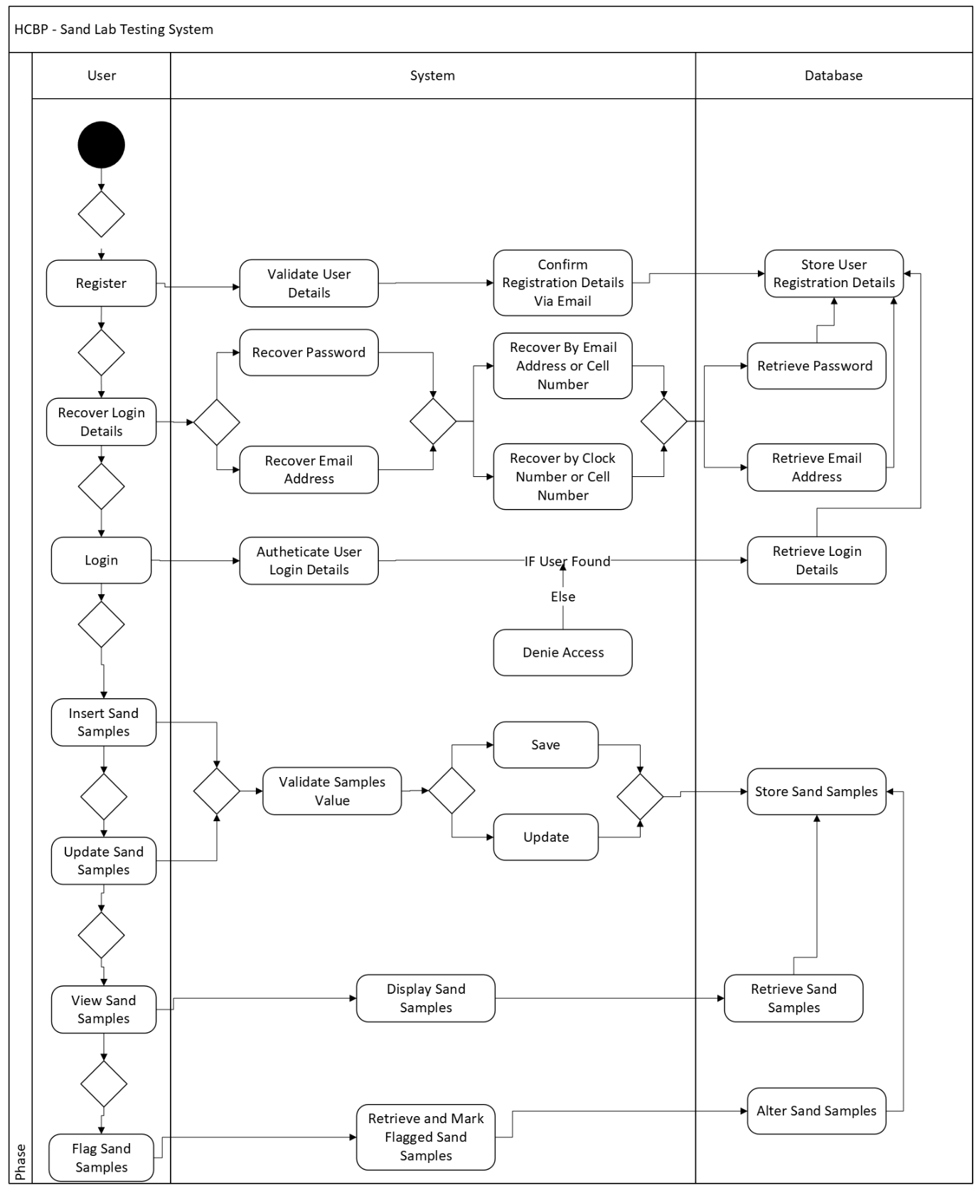

3.3 Database Design Diagram

3.3.1 ERD – Entity Relationship Diagram
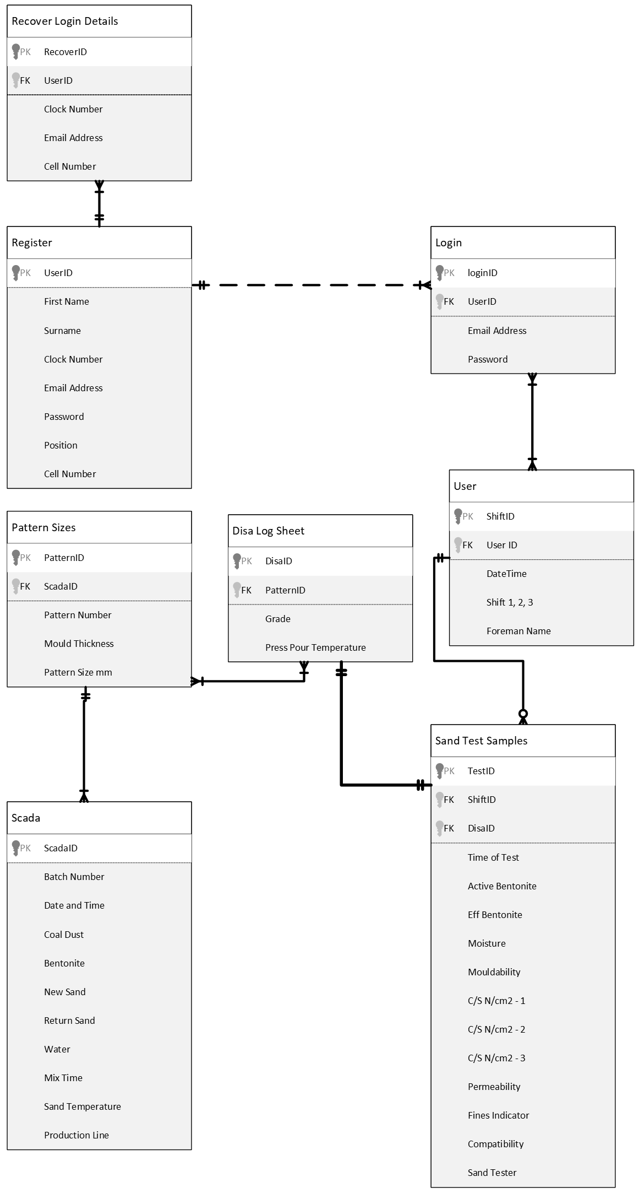

NON – FUNCTIONAL REQUIREMENTS

4.1 Technical Requirements

4.1.1 Platform
- The system will run on:
  - Microsoft Edge, Google Chrome or Web Browser
  - Mobile Device/ Tablet
  - SQL Server for database backend
  - Accessible via IIS (Internet Information Services)
  - APK Link for Mobile/Tablet Version Download

4.1.2 Technology Stack
  - Frontend: Android Studio - Flutter
  - Backend: Visual Studio Code – Node.js and Express
  - Database: Microsoft SQL Server

4.1.3 Architectural Design Patterns
  - MVC – Back End
  - MVVM – Front End
  - Database – Erd
      - Tables
      - Stored Procedure

4.2 Data Requirements

4.2.1 Data Storage
  - MSQL Server Database
  - Data Schema
  - Stored Procedure

4.2.2 Data Input
  - Validated User Inputs
  - Domain @Magotteauxgmsa.com
  - Authentication
  - Authorisation

4.2.3 Usability Requirements
  - Android / IOS Cell phone
  - Tablet / iPad
  - Desktop / Laptop

4.3 Business / System Feature Requirements
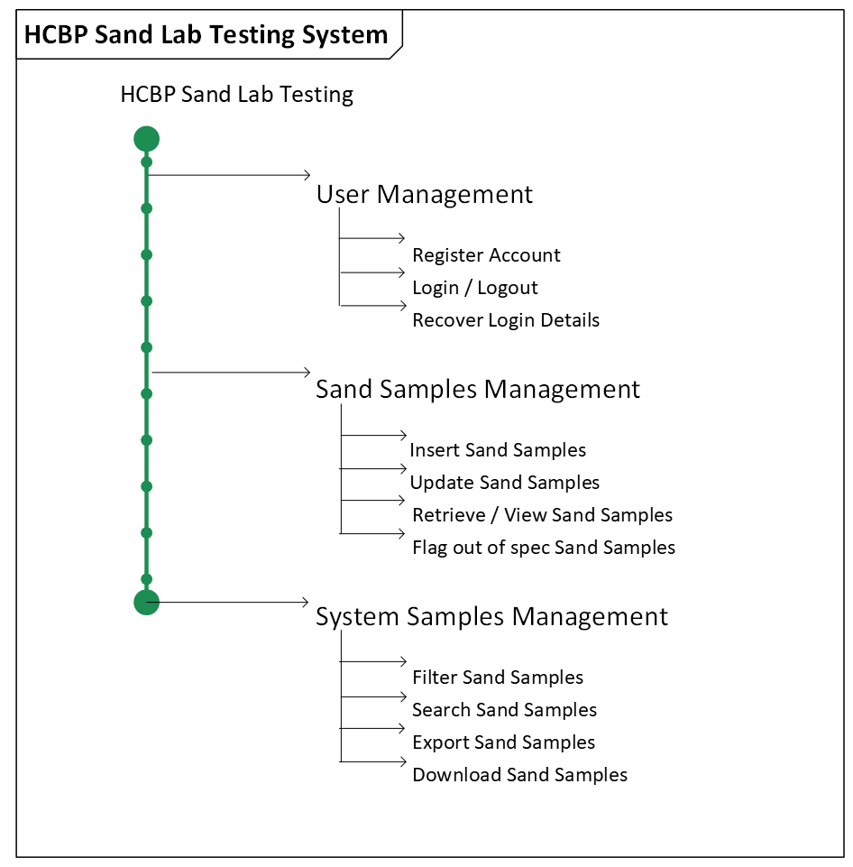

4.3.1 User Management
- Register Account (Authorisation)
- Login / Logout (Authentication)
- Recover Login Details (Authentication)

4.3.2 Sand Samples Management
- Insert Sand Samples
- Update Sand Samples
- Retrieve / View Sand Samples
- Flag out of spec Sand Samples

4.3.3 System Sand Samples Management
- Filter Sand Samples
- Search Sand Samples
- Export Sand Samples
- Download Sand Samples

TIMELINE
- Development Start: 27th October 2025
- Testing Phase: Frequently after Updates
- Go-Live: Frequently after updates approval

RESOURCES
- Team:
  - MIS Technician Trainee

CONCLUSION

